
SRI SIDDAGANGA HIGHER PRIMARY SCHOOL
Affiliated to CBSE New Delhi
Chandra Layout, 1 Stage, II Phase, Bangalore -72
MITERM EXAMINATION, 2025 -26
Subject: Environmental Studies
CLASS: II Max Marks: 50
Date: 23 / 09 / 2025 Duration: 2 Hours

Name:_________________________ Roll No:____ Section_______

Observation | Knowledge | Understanding | Skill | Total
05 | 25 | 15 | 5 | 50

General instructions
1.Handwriting should be neat and legible.
2. Avoid overwriting.
OBSERVATION
I. Observe the following pictures and write their names. 1X5=5

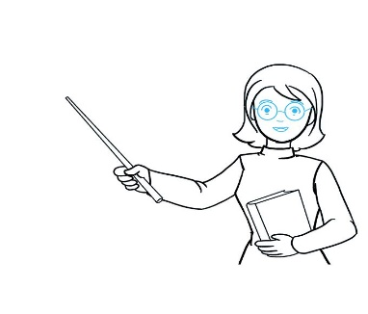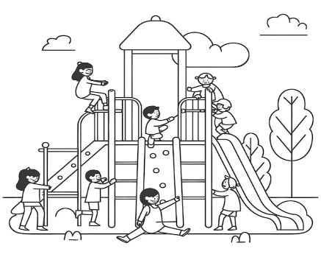

_________________ ________________ _________________________



______________ _________________

KNOWLEDGE

II. Fill in the blanks: 1X8= 8

1. I use my _______________ to taste food.
2. Cricket is an example of an _____________ games .
3. We should hold the handlebar of a bicycle ______________.
4. A _____________ fix broken taps.
5. A _________________ is place where police officers work.
6. We should not _____________ the school building.
7. A _________________ builds wall using bricks and cement.
8. The goat is a _____________ animal.

III. Write the missing letters. ½ X4=2
1) I __ D E P __ N D __ N C __
2) C L __ M B __ R S
3) V___G___T A B L E S
4) E X E___R C __S E
IV. Name the following . 1 X 3 = 3
- It helps us to smell a jasmine_________.

- The state of being safe called _______________.

- A person who sells fruits and vegetables_______________.

V. Match the following. 1X4=4

 | A |  | B
1 | Pumps blood | A | Rose
2 | Walking , jogging | B | bread
3 | Energy giving foods | C | forms of exercises
4 | Shrub | D | heart

UNDERSTANDING
III. A) Answer the following questions in one word or sentences: 1X10=10
- How do silkworms help us?
Ans. ____________________________________________________________________.

2. Give two examples for herb.
Ans. ____________________________________________________________________
________________________________________________________________________.

3. When is Christmas celebrated every year ?
Ans_____________________________________________________________________.

4. Who mends our shoes ?
Ans.____________________________________________________________________
________________________________________________________________________.
5. Why are exercise important to us ?
Ans.____________________________________________________________________
________________________________________________________________________.
6. Where do doctors and nurses work ?
Ans. ____________________________________________________________________.
7. What is single parent family?
Ans. ____________________________________________________________________.
8. Where should you cross a road ?
Ans . ____________________________________________________________________.
9. Name any two external organs .
Ans. ____________________________________________________________________.
10. Name two outdoor games.
Ans. ____________________________________________________________________.

IV. Answer the following questions in two or three sentence. 2X7=14
- How does members of family help us ______________________________________________________________________________________________________________________________________________
- Name any four places in your neighbourhood.
Ans.__ __________-- _________-________________________________________________________________________________________________________________________________ _____________________________________________________________ ___________________________________________________________________________________________________________________________________________________________.

- Write any two ways in which can take care of our school .
Ans. __________________________________________________________________
_____________________________________________________________________________________________________________________________________________.

- Name the religious festivals .
Ans. __________________________________________________________________
_____________________________________________________________________________________________________________________________________________.

- Why do animals move from one place to another place?
Ans. __________________________________________________________________
_____________________________________________________________________________________________________________________________________________.

- Write any two wild and domestic animals.
Ans. __________________________________________________________________
_____________________________________________________________________________________________________________________________________________.
- How many sense organs are there ? Name them
Ans. __________________________________________________________________
____________________________________________________________________________________________________________________________________________________________________________________________________________________.

SKILL
IV.A)Draw and colour picture of plant label it and write few lines about it. 2

B) Locate the given places in outline map of India and colour the
places. 1X2=2
1. Karnataka (Yellow Colour) 2. Jammu Kashmir(Orange Colour)
